**06-Strings inPython**

**Ex. No. : 6.1 Date: 1/5/24**

**Register No.: 231801160 Name: Sathvikha**

## CountChars

Write a python program to count all letters, digits, and special symbols respectively from a given string

Forexample:

InputResult rec@123

3

3

1

# Program:

a=input() c,d,s=0,0,0

foriinrange(len(a)): if(a[i].isalpha()):

c+=1

elif(a[i].isdigit()): d+=1

else:

s+=1

print(c,d,s,sep="\n")

# Output:

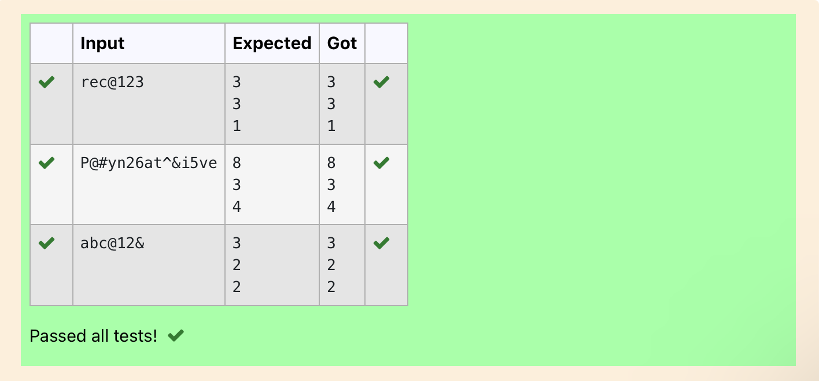

**Ex. No. : 6.2 Date: 1/5/24**

**Register No.: 231801160 Name: Sathvikha**

## DecompresstheString

Assumethatthegivenstringhasenoughmemory.Don'tuseanyextraspace(IN- PLACE)

SampleInput1 a2b4c6

SampleOutput1 aabbbbcccccc

# Program:

importre a=input()

all=re.findall('\d+',a) all_w=re.findall('[a-z]',a) b=''

fori,jinzip(all,all_w): b+=int(i)*j

print(b)

# Output:

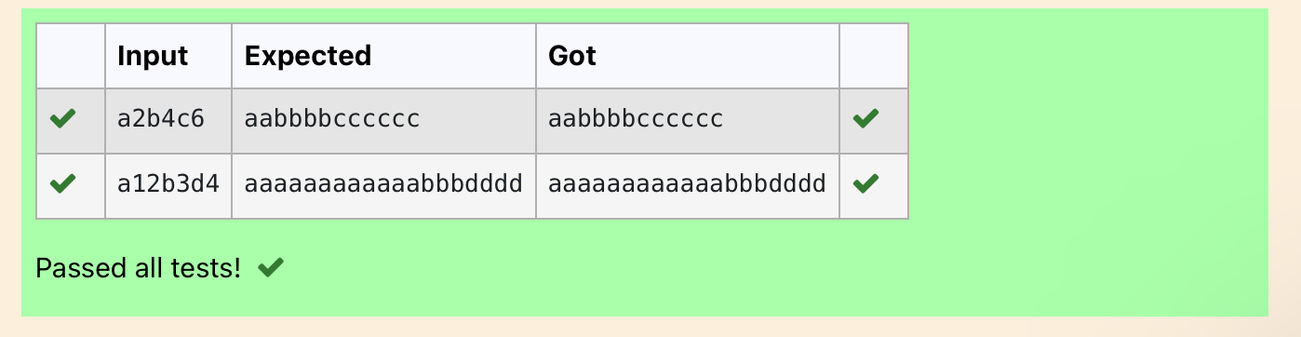

**Ex. No. : 6.3 Date: 1/5/24**

**Register No.: 231801160 Name: Sathvikha**

## FirstNCommonChars

TwostringvaluesS1,S2arepassedas theinput. TheprogrammustprintfirstN characters present in S1 which are also present in S2.

Input Format:

The first line contains S1. ThesecondlinecontainsS2. The third line contains N.

OutputFormat:

Thefirstline containstheN characterspresentinS1whichare alsopresentinS2. Boundary Conditions:

2<=N<=10

2<=LengthofS1,S2<= 1000 Example Input/Output 1:

Input:

abcbdecdefghbb3

Output:

bcdNote:

boccurstwiceincommonbutmustbeprintedonlyonce.

# Program:

a=input() b=input() C=''

d=int(input())

foriinrange(len(a)):

if(len(C)-d==0): break

else:

if(a[i]inb):

if(a[i]notinC): C+=a[i]

print (C)

# Output:

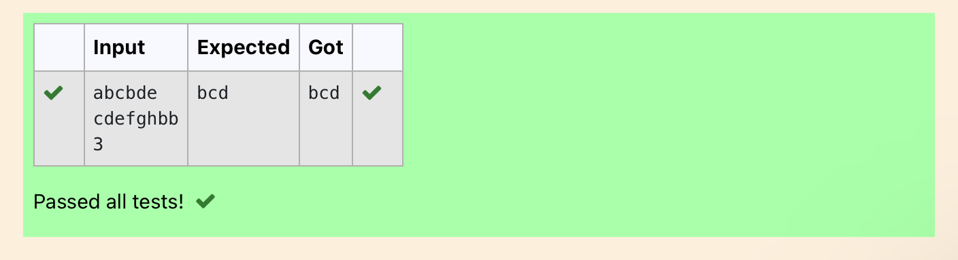

**Ex. No. : 6.4 Date: 1/5/24**

**Register No.: 231801160 Name: Sathvikha**

## RemoveCharacters

GiventwoStringss1ands2,removeallthecharactersfroms1whichispresentin s2.

Constraints

1<=stringlength<=200

SampleInput1 experience

enc

SampleOutput1 xpri

# Program:

defremove_chars(s1,s2):

return''.join([charforcharins1ifcharnot ins2]) s1=input()

s2=input()

result=remove_chars(s1,s2) print(result)

# Output:

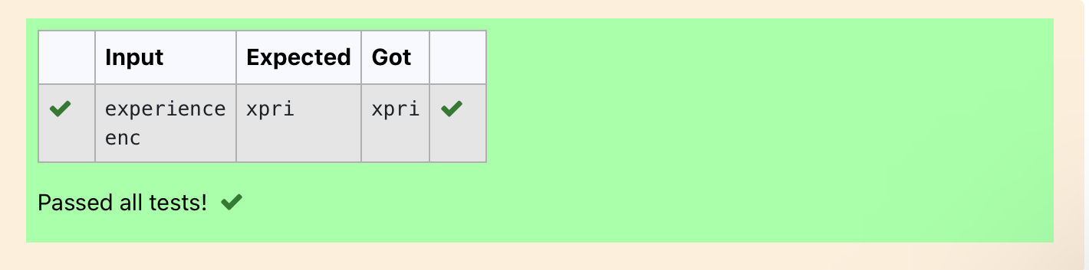

**Ex. No. : 6.5 Date: 1/5/24**

**Register No.: 231801160 Name: Sathvikha**

## RemovePalindromeWords

Stringshouldcontainonlythewordsarenotpalindrome.

SampleInput1

Malayalamismymothertongue

SampleOutput1

ismymothertongue

Forexample:

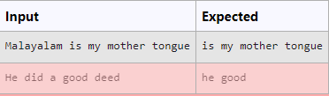

# Program:

a=[]

a=input() b=a.split() for i in b:

k=i.lower() ifk!=k[::-1]:

print(k,end='')

# Output:

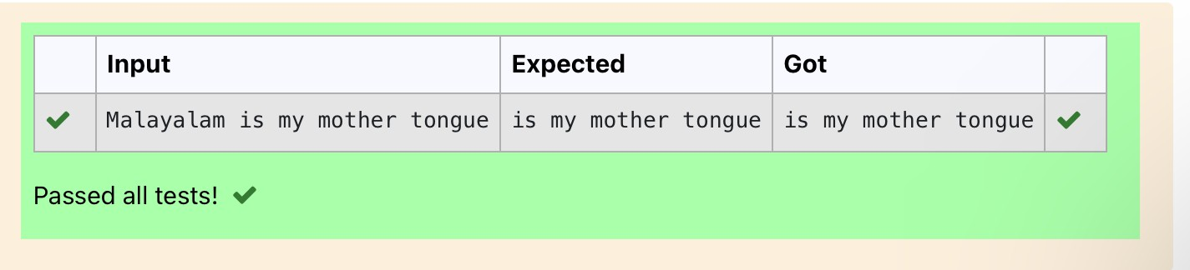

**Ex. No. : 6.6 Date: 1/5/24**

**Register No.: 231801160 Name: Sathvikha**

## ReturnSecondWorldinUppercase

Write a programthat takesasinput a string (sentence),and returnsitssecond word in uppercase.

Forexample:

If input is “Wipro Technologies Bangalore” the function should return “TECHNOLOGIES”

Ifinputis“HelloWorld”thefunctionshouldreturn“WORLD” If input is “Hello” the program should return “LESS”

NOTE1:Ifinputisasentencewithlessthan2words,theprogramshouldreturnthe word “LESS”.

NOTE2:Theresultshouldhaveno leadingortrailingspaces. For example:

InputResult

WiproTechnologiesBangalore TECHNOLOGIES

HelloWorld WORLD

Hello LESS

# Program:

f=input() s=f.split() iflen(s)>1: c=s[1]

print(c.upper()) else:

print("LESS")

# Output:

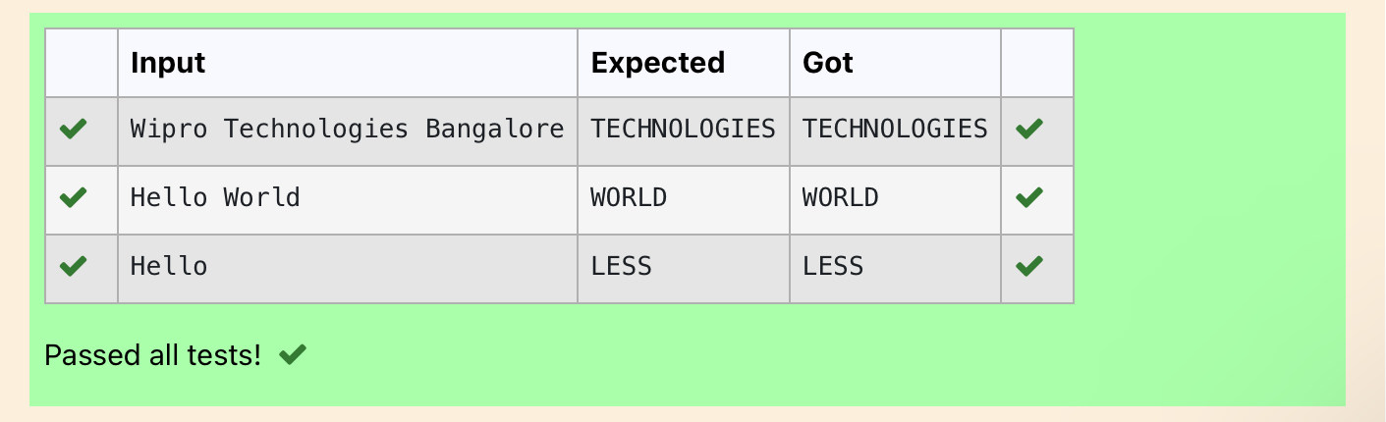

**Ex. No. : 6.7 Date: 1/5/24**

**Register No.: 231801160 Name: Sathvikha**

## ReversString

Reverse a string without affecting special characters. Given a string S, containing special characters and all the alphabets, reverse the string without affecting the positions of the special characters.

Input:

A&B Output:

B&A

Explanation:Asweignore'&'and

Asweignore'&'andthenreverse,soansweris"B&A".

Forexample:

InputResult A&x#

x&A#

# Program:

defreverse_string(s): s = list(s)

l,r=0,len(s)-1

whilel<r:

ifnots[l].isalpha(): l += 1

elifnots[r].isalpha(): r -= 1

else:

s[l],s[r]=s[r],s[l] l += 1

r-=1

return''.join(s) # Test Cases

print(reverse_string(input()))#Output:"B&A"

# Output:

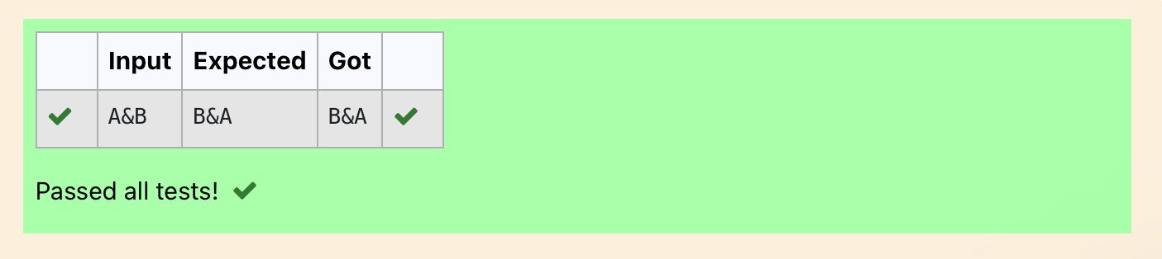

**Ex. No. : 6.8 Date: 1/5/24**

**Register No.: 231801160 Name: Sathvikha**

## StringcharactersbalanceTest

Write a program to checkif two strings are balanced. For example,strings s1 and s2 arebalancedifall the charactersinthe s1 arepresentins2. The character’sposition doesn’t matter. If balanced display as "true" ,otherwise "false".

Forexample:

InputResult Yn

PYnativeTrue

# Program:

a=input() b=input() if a in b:

print("True") else:

print("False")

# Output:

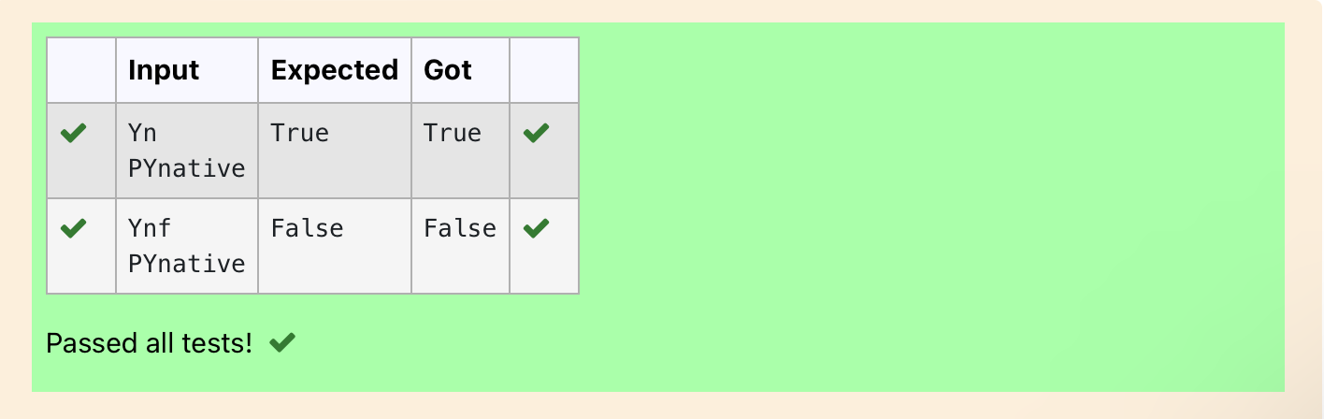

**Ex. No. : 6.9 Date: 1/5/24**

**Register No.: 231801160 Name: Sathvikha**

## UniqueNames

Inthisexercise,youwill createaprogramthatreadswordsfromtheuseruntilthe user enters a blank line. After the user enters a blank line your program should display eachword entered by theuserexactlyonce.Thewords should bedisplayed in the same order that they were first entered. For example, if the user enters: **Input:**

first second first third second

thenyourprogramshoulddisplay:

### Output:

first second third

# Program:

a,c=[],[]

foriinrange(0,5): b=input() a.append(b)

foriinrange(len(a)): if(a[i] not in c):

c.append(a[i])

print(a[i])

# Output:

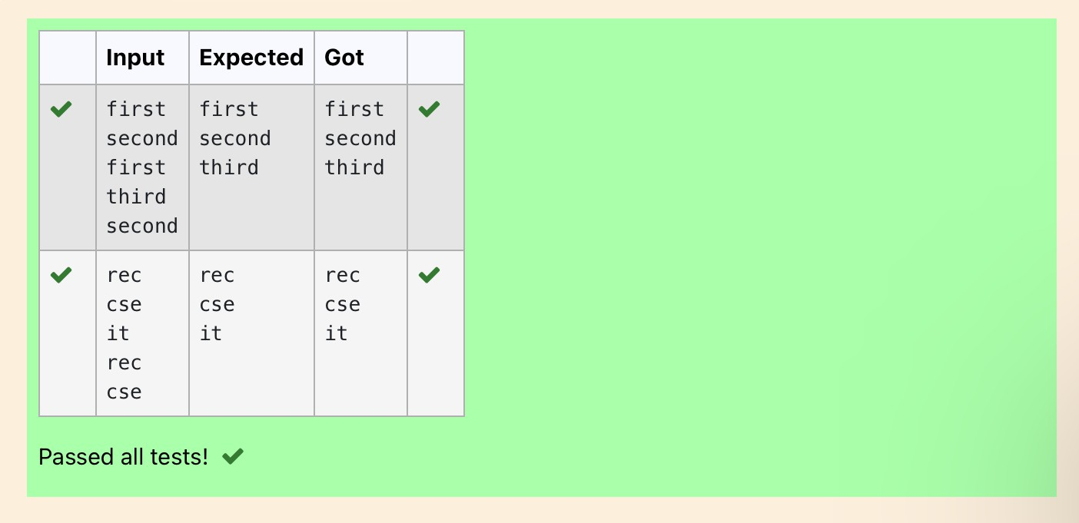

**Ex. No. : 6.10 Date: 1/5/24**

**Register No.: 231801160 Name: Sathvikha**

## UsernameDomainExtension

Given a string S which is of the format [USERNAME@DOMAIN.EXTENSION,](mailto:USERNAME@DOMAIN.EXTENSION) theprogram must print the EXTENSION, DOMAIN, USERNAME in the reverse order.

### InputFormat:

ThefirstlinecontainsS.

### OutputFormat:

The first line contains EXTENSION. The second line contains DOMAIN. ThethirdlinecontainsUSERNAME.

### BoundaryCondition:

1 <= Length of S <= 100 ExampleInput/Output1: **Input**:

[vijayakumar.r@rajalakshmi.edu.in](mailto:vijayakumar.r@rajalakshmi.edu.in)

### Output:

edu.in rajalakshmivijayakumar.r

# Program:

a=input()

ext=a.split('@')[0]

dom=a.split('@')[1].split('.')[0] userno = a.find('.')

user = a[userno+1:] print(user) print(dom,end='\n') print(ext,end='\n')

Output:

